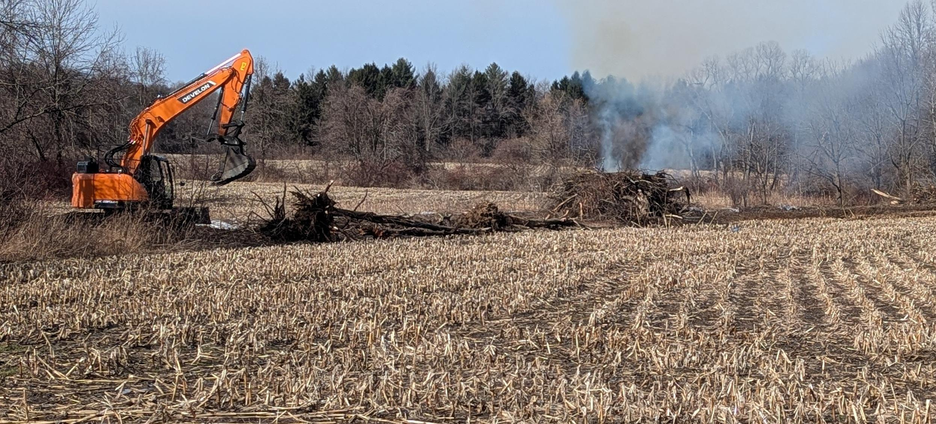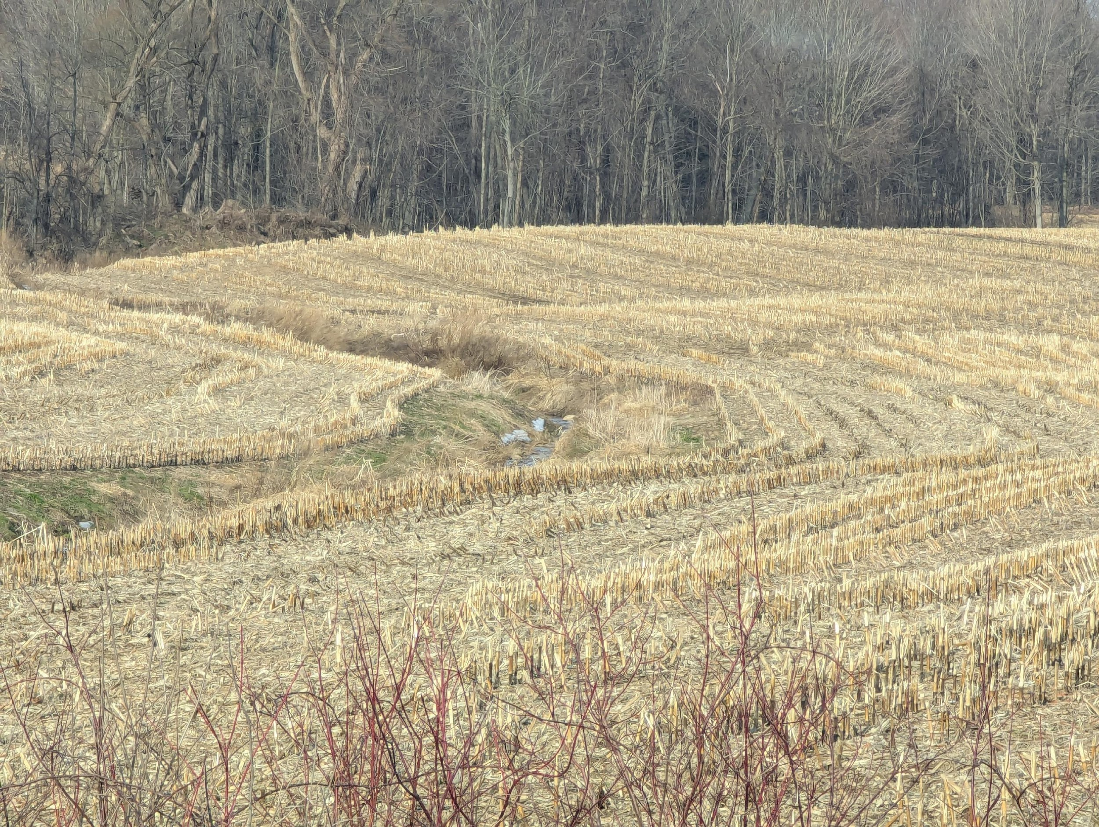

Field ‘hedgerows’ around drainage ditches are also being removed. This one was a roadside field noted on March 15 2025. The approximately 20 foot width of the growth acted as a buffer of sorts trapping at least some eroded soil and fertilizers. Hedgerows also serve as corridors and refuges for the movement of birds, animals and insects through the monoculture edges. Below is another field with the “buffer” of sorts removed.

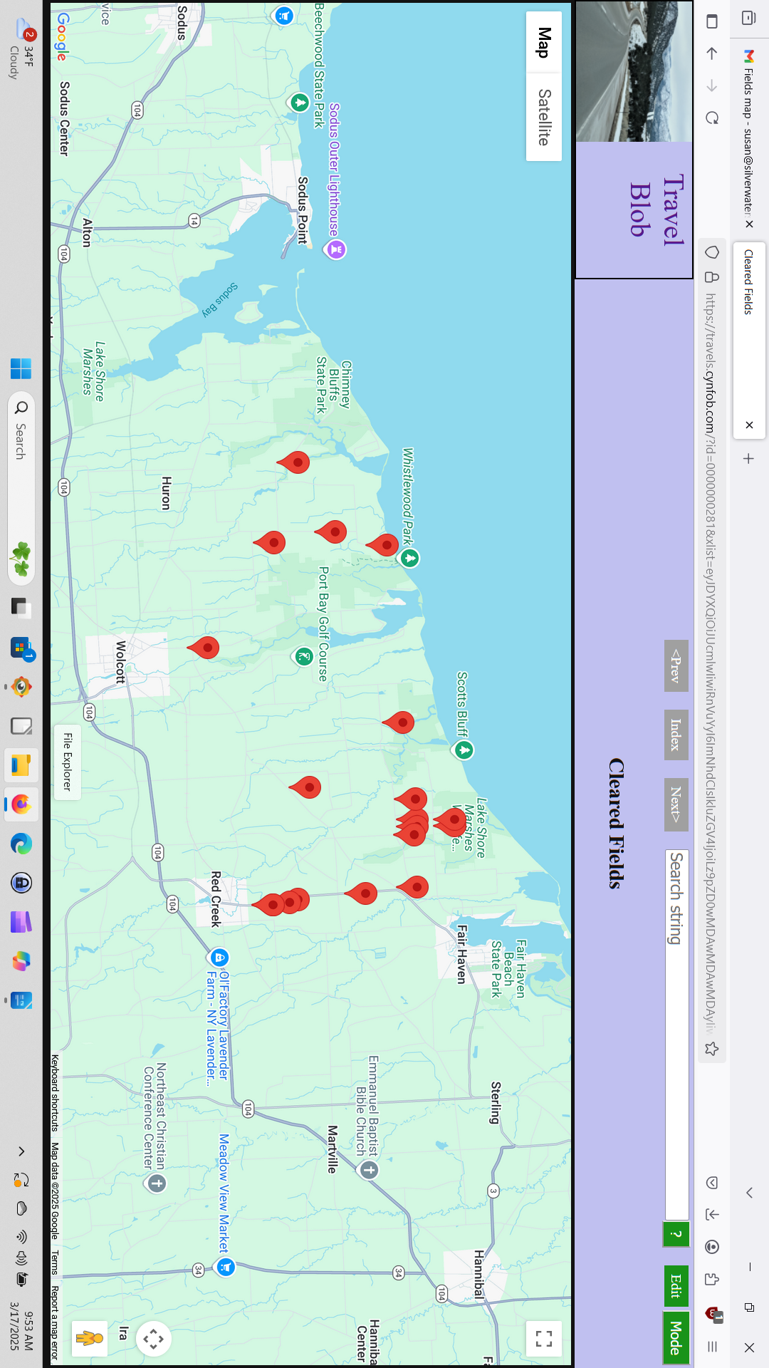

Map 1. A partial display of recently cleared fields within ten miles of my home. These roadside locations are an under estimate of total cleared and represent fields along my various Meals on Wheels routes only. They do not include fields with no road frontage. Only fields with obvious cleared logs, brush and root balls bulldozed to the edges are noted. These are often burned and so would not be counted by my informal survey. Acreages run 20 to 50 acres each.